Miami-Dade County Public Schools
Department of Secondary English Language Arts

DISTRICT WRITING PRE-TEST ASSESSMENT

8TH GRADE
INFORMAtive/EXPLANATORY PROMPT

Name: ______________________________
Teacher: _________________ Per: ____

Source 1: What Is Cyberbullying
StopBullying.gov
1 | Cyberbullying is bullying that takes place over digital devices like cell phones, computers, and tablets. Cyberbullying can occur through SMS, Text, and apps, or online in social media, forums, or gaming where people can view, participate in, or share content. Cyberbullying includes sending, posting, or sharing negative, harmful, false, or mean content about someone else. It can include sharing personal or private information about someone else causing embarrassment or humiliation. Some cyberbullying crosses the line into unlawful or criminal behavior.
2 | The most common places where cyberbullying occurs are:  - Social Media, such as Facebook, Instagram, Snapchat, and Twitter  - SMS (Short Message Service) also known as Text Message sent through devices  - Instant Message (via devices, email provider services, apps, and social media messaging features)  - Email
 | Special Concerns
3 | With the prevalence of social media and digital forums, comments, photos, posts, and content shared by individuals can often be viewed by strangers as well as acquaintances. The content an individual shares online – both their personal content as well as any negative, mean, or hurtful content – creates a kind of permanent public record of their views, activities, and behavior. This public record can be thought of as an online reputation, which may be accessible to schools, employers, colleges, clubs, and others who may be researching an individual now or in the future. Cyberbullying can harm the online reputations of everyone involved – not just the person being bullied, but those doing the bullying or participating in it.
4 | Cyberbullying has unique concerns in that it can be:  Persistent – Digital devices offer an ability to immediately and continuously communicate 24 hours a day, so it can be difficult for children experiencing cyberbullying to find relief.  Permanent – Most information communicated electronically is permanent and public, if not reported and removed. A negative online reputation, including for those who bully, can impact college admissions, employment, and other areas of life.  Hard to Notice – Because teachers and parents may not overhear or see cyberbullying taking place, it is harder to recognize.
 | Laws and Sanctions
5 | Although all states have laws requiring schools to respond to bullying, many states do not include cyberbullying under these laws or specify the role schools should play in responding to bullying that takes place outside of school. Schools may take action either as required by law, or with local or school policies that allow them to discipline or take other action. Some states also have provisions to address bullying if it affects school performance.

Source 2: The Effects of Cyberbullying
By Sherri Gordon, Updated July 24, 2019
6 | Bullying, no matter whether it is traditional bullying or cyberbullying, causes significant emotional and psychological distress. In fact, just like any other victim of bullying, cyberbullied kids experience anxiety, fear, depression, and low self-esteem. They also may deal with low self-esteem, experience physical symptoms, and struggle academically. But targets of cyberbullying also experience some unique consequences and negative feelings.
 | Common Effects and Feelings Associated with Cyberbullying
7 | Feel Overwhelmed: Being targeted by cyberbullies is crushing. It can feel at times like the entire world knows what it is going on. Sometimes the stress of dealing with cyberbullying can cause kids to feel like the situation is more than they can handle.
8 | Feel Vulnerable and Powerless: Victims of cyberbullying often find it difficult to feel safe. Typically, this is because the bullying can invade their home through a computer or cell phone at any time of day. They no longer have a place where they can escape. To a victim, it feels like bullying is everywhere. Additionally, because the bullies can remain anonymous, this can escalate feelings of fear. Kids who are targeted have no idea who is inflicting the pain.
9 | Feel Exposed and Humiliated: Because cyberbullying occurs in cyberspace, online bullying feels permanent. Kids know that once something is out there, it will always be out there. When cyberbullying occurs, the nasty posts, messages or texts can be shared with multitudes of people. The sheer volume of people that know about the bullying can lead to intense feelings of humiliation.
10 | Feel Dissatisfied with Who They Are: Cyberbullying often attacks victims where they are most vulnerable. As a result, targets of cyberbullying often begin to doubt their worth and value. They may respond to these feelings by harming themselves in some way.
11 | For instance, if a girl is called fat, she may begin a crash diet with the belief that if she alters how she looks then the bullying will stop.
13 | Feel Angry and Vengeful: Sometimes victims of cyberbullying will get angry about what is happening to them. As a result, they plot revenge and engage in retaliation. This approach is dangerous because it keeps them locked in the bully-victim cycle. It is always better to forgive a bully than it is to get even.
14 | Feel Disinterested in Life. When cyberbullying is ongoing, victims often relate to the world around them differently than others. For many, life can feel hopeless and meaningless. They lose interest in things they once enjoyed and spend less time interacting with family and friends.
15 | Feel Alone and Isolated:¹﻿ Cyberbullying sometimes causes teens to be excluded and ostracized¹ at school. This experience is particularly painful because friends are crucial at this age. When kids don’t have friends, this can lead to more bullying.
16 | What's more, when cyberbullying occurs, most people recommend shutting off the computer or turning off the cell phone. But, for teens, this often means cutting off communication with their world. Their phones and their computers are one of the most important ways they communicate with others. If that option for communication is removed, they can feel secluded and cut off from their world.
17 | Feel Disinterested in School: Cyberbullying victims often have much higher rates of absenteeism at school than non-bullied kids.²﻿ They skip school to avoid facing the kids bullying them or because they are embarrassed and humiliated by the messages that were shared. Their grades suffer too because they find it difficult to concentrate or study because of the anxiety and stress the bullying causes. And in some cases, kids will either drop out of school or lose interest in continuing their education after high school.
18 | Feel Anxious and Depressed: Victims of cyberbullying often succumb² to anxiety, depression and other stress-related conditions.﻿ This occurs primarily because cyberbullying erodes their self-confidence and self-esteem.
19 | Feel Suicidal: Cyberbullying increases the risk of suicide.³﻿ Kids that are constantly tormented by peers through text messages, instant messaging, social media, and other outlets, often begin to feel hopeless. They may even begin to feel like the only way to escape the pain is through suicide. As a result, they may fantasize about ending their life in order to escape their tormentors.

1 ostracized - exclude (someone) from a society or group.
2 succumb – submit

Source 3: Short Term and Long Term Effects of Bullying
Article by: Katie Hurley, LCSW
20 | Bullying is a serious threat to our youth today. According to the Centers for Disease Control and Prevention (CDC), bullying affects 20% of high school students and cyberbullying affects 16% of high school students. Surveys compiled by the CDC also show that 33% of students ages 12-18 who reported bullying at school and 27% of students ages 12-18 who reported cyberbullying indicated that they were bullied at least once or twice a month. Middle schools reported the highest rate of bullying (25%), at least once a week.
21 | Bullying can have negative short and long-term consequences for both the victim and the bully. While traditional intervention for bullying tends to include getting help for the victim and establishing consequences for the bully, it should be noted that both the victim and the bully benefit from psychosocial¹ support.
 | Effects of bullying
22 | All kids are different and are likely to exhibit varying behaviors during or after bullying by a peer. With relational aggression on the rise and cyberbullying easier than ever, it should be noted that bullying can be ongoing for long periods of time before students seek help.
23 | A UCLA study of 2,300 students in eleven middle schools in Los Angeles found that a high level of bullying was associated with lower grades across three years of middle school. Students who were rated as the most bullied performed significantly worse academically than their peers.
24 | Short-term effects on the bullied victim can include:  • Social isolation  • Feelings of shame  • Sleep disturbance  • Changes in eating habits  • Low self-esteem  • School avoidance  • Symptoms of anxiety  • Bedwetting  • Higher risk of illness  • Psychosomatic symptoms (stomachaches, headaches, muscle aches, other physical complaints with no known medical cause)  • Poor school performance  • Symptoms of depression
25 | Short-term effects of bullying for the bully
 | While it can be difficult to empathize with the bully, it’s essential that parents and school officials recognize that bullies engage in bullying behavior for a reason. Without help, the behavior will continue, and potentially worsen, over time.
26 | Effects on the bully can include:  • Poor school performance (missed school due to suspensions increases this risk)  • Increased truancy risk  • Difficulty maintaining social relationships  • Increased risk of substance abuse
27 | One longitudinal study² led by a group of scientists in Norway investigated the long-term psychological effects of adolescents. Results of the study indicated that all groups involved in bullying during adolescence, both bullies and victims, experienced adverse mental health outcomes in adulthood. While the victims showed a high level of depressive symptoms in adulthood, both groups experienced an increased risk of psychiatric hospitalization due to mental health disorders.
28 | Long-term risks of bullying for the victim  With immediate and proper mental health treatment and support systems in place, victims can stave³ off some of the potential long-term consequences of bullying. Without intervention, however, kids are at risk for the following:  • Chronic depression  • Increased risk of suicidal thoughts, suicide plans, and suicide attempts  • Anxiety disorders  • Post-traumatic stress disorder  • Poor general health  • Self-destructive behavior, including self-harm  • Substance abuse  • Difficulty establishing trusting, reciprocal friendships and relationships
29 | Long-term effects of bullying for the bully
Without proper treatment, bullying behavior is likely to continue into adulthood.
• Risk of spousal or child abuse
• Risk of antisocial behavior
• Substance abuse
• Less likely to be educated or employed

30 | Childhood bullying has serious effects on both short and long-term health of children. Immediate intervention and long-term follow-up can help mediate⁴ some of these effects. It is imperative that schools, families, and communities work together to understand bullying and its consequences and find ways to decrease, and hopefully eradicate⁵, bullying both in schools and communities.
1 psychosocial – the relationship of society and individual thought and behavior.
2 longitudinal study – research method in which data is gathered for the same subjects repeatedly over a
period of time
3 stave – break by force
4 mediate – intercede
5 eradicate – eliminate
Source 4: A Majority of Teens Have Experienced Some Form of Cyberbullying
Pew Research Center
September 27, 2018
31 | 59% of U.S. teens have been bullied or harassed online, and a similar share says it's a major problem for people their age. At the same time, teens mostly think teachers, social media companies and politicians are failing at addressing this issue.
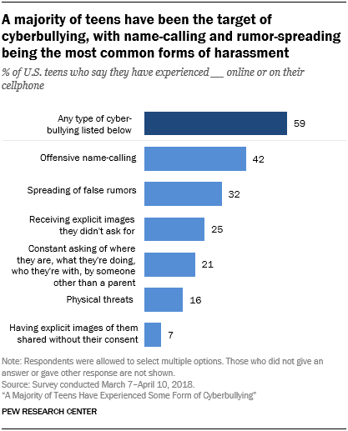
While texting and digital messaging are a central
way teens build and maintain relationships, this level of connectivity may lead to potentially troubling and nonconsensual¹ exchanges.

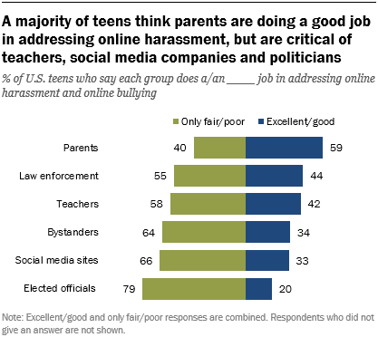
Teens’ views on how well each of these groups is handling this issue vary little by their own personal experiences with cyberbullying – that is, bullied teens are no more critical than their non-bullied peers.

1 nonconsensual – not agreed to by one or more of the people involved
Writing Prompt
Write an explanatory essay to inform your entire student body about the effects cyberbullying have on both the victim and the bully. Your essay must be based on ideas and information that can be found in the passage set.

Manage your time carefully so that you can
• read the passages;
• plan your response;
• write your response; and
• revise and edit your response.
Be sure to
• use evidence from multiple sources; and
• avoid overly relying on one source.
Your response should be in the form of a multi-paragraph essay. Write
your response in the space provided.

